The future of higher education in the UK and Australia: What can we learn from each other?

Tuesday, 12 Sep 2017 13:30 - 16:00

Australian High Commission, Strand, London, WC2B 4LA

Australia, UK, higher education: Some thoughts
Simon Marginson / UCL IOE & CGHE

[opening slide]
Thank you David [Sweeney] for those encouraging words about CGHE. I hope to do something different today, about Australia and UK.
Moving between Australia and England in higher education is deceptively easy. University structures, organisation, and cultures are so similar they seem part of a common system. Government and policy cultures overlap heavily. Policy borrowing goes back and forth. Yet there are differences.

[History, Geography, Demography]
The UK is defined by its long history, its Atlantic location on the edge of Western Europe, its trade in Europe and its present global role as a European finance centre, its proximity to Middle East and Africa, and the massive centripetal force exerted by London. Australia is shaped by its dispersed capital cities on the coastal rim, and its combination of British history and Asia-proximate geography and economy. It follows British norms in law, government, policy, business, the professions, education and science. It is influenced by the United States, as are all English-speaking nations. However, Australia is moving inexorably towards Asia, especially China and Southeast Asia. In tectonic terms, it is moving northwards at only 2 centimetres a year. Other convergence is faster. How far this will go, and what will be the Anglo-Asian hybrid that results, is the unknown question.
In the UK 14 per cent are foreign born, many in living London; in Australia it is 28 per cent, again concentrated, in Melbourne and Sydney. In Sydney the foreign born are 40 per cent, and increasingly Asian. Settler states are typically more tolerant of migration and more economically dependent on it. The recurring periods of opposition to migration and nativist identity are shorter in Australia, and run less deep. Australia wobbled over Asian migration in the second half of the 1990s and 2009-2011. The UK’s present anti-migration wobble has lasted for a and taken the country out of Europe, thus changing its trajectory and identity, and inhibited international student recruitment and regulation. Onshore UK international student numbers have stopped growing. In Australia annual growth has returned to double digit levels.

[State and Political Culture]
The UK invented neoliberal government. Australia was a thoroughgoing early adopter. Both higher education systems are located in Treasury-led polities where policy issues are normally debated in a primarily economic framework, though issues of national identity in the UK have partly disrupted that. Both higher education systems are subject to strong national policy, though tuition and student support arrangements are devolved to the four UK nations. In Australia the caveat is the federation, but by gaining a monopoly of income taxing power in World War II the Commonwealth secured economic dominance and has largely taken over higher education policy and regulation. The state plays a somewhat larger role in Queensland than in other parts of the country, through the development of facilities and research.
Social and political cultures differ in certain ways. England has a robust class structure, buttressed by the independent schools, Oxford and Cambridge. There is still surprising deference to aristocracy; and it seems the ‘triumph of the gentry’, the historians’ verdict on the 17th century civil war, still applies. Democracy has been thickly layered over the top, bringing with it social inclusion and nominally, equal respect for all. Yet there is higher income inequality and lower social mobility, than in nearby Northwestern Europe.
Australia shares the trend to growing income inequality but the incidence of social mobility is greater than in UK, though not as high as Canada. Australia’s per capita income at $47,000 US exceeds the UK at $44,000 yet there are less great fortunes. Australia has meritocratic public values with little patience for inherited claims—ultimately, wealth and status are only legitimated by competition. Equality of opportunity, including opportunities to enter post-school education, is central. A spare sense of entitlement and inclusion, and rejection of extremes of top or bottom, are pervasive characteristics of Australian life and of higher education. Equality of treatment, although not of condition or outcomes, is expected. Quasi-markets and targeting lower expectations about common economic and social rights and reduce potential income redistribution. It’s not generous, and above the level of minimum sustenance it is competitive, but everybody is on the bus.

[Intellectual Life]
There are also differences in intellectual life. The UK has a remarkable level of serious journalism and a vibrant policy discussion centred on London. In Australia the policy conversation is dispersed and the journalism smaller, with a lesser range of quality. Except perhaps for Medicine and allied sciences, and pockets of research here and there, the disciplines are stronger in UK. In UK universities there is a more robust commitment to ideas and inquiry as ends in themselves. Australian universities are more instrumental. That’s how it looks to me. I recognise that these are controversial and unprovable judgments. And there are exceptions to all such generalisations.

[Dreams]
Perhaps, also, the dreams are different.

[Robin Hood 1]

What is the emblematic national legend? In the UK, where the concerns are class and inequality, Robin Hood is deeply felt. Robs from the rich and gives to the poor. Redistribution and social justice, instigated at the level of the Saxon village, under then nose of the centralising Norman state.

[Robin Hood 2]

But every legend can be reworked to fit the times. And in a neoliberal era, Robin Hood’s redistribution has been remade as an early tax revolt. Perhaps this suggests that neoliberalism is a pre-Norman echo, which would help to explain the popular tolerance of neoliberal ideas. Though I think the version in the slide is more American than English!

[Magic Pudding]

Whereas in Australia … the deepest dream is not about village justice in a pre-Norman communitarian society, prior to the state. It is about the state itself. It is the Magic Pudding. No matter how often it is eaten, it always re-forms itself in order to be eaten again. It’s everything its owners need. Their only concern is to keep control of it, to keep their privileged access to it, from the Pudding Thieves who keep on stealing it. This is the legacy of the colonial period, when the state provided all—although ingenuity, improvisation and a well developed and highly competitive survival instinct were also essential. That’s the true Australia. And every university wants a magic pudding!

[Participation and Equity]
What are the outcomes of these respective national cultures for participation and equity in higher education? Both emphasise widening participation, yet are more committed to equity of access and process than hard equality of social outcomes, except in relation to gender. Location plays a larger role in inequality in the UK than in Australia, where a core principle of public policy is to provide equivalent services even in remote locations.
Australia retains direct state funding for all domestic undergraduate student places in higher education, though this is low in law and business studies. The UK provides considerable public subsidies—but subsidies for non STEM students are confined to the underwriting of individual access, through the public guarantee of non-repaid loans. This implies that externalities are low or non-existent, except in relation to opportunity, meaning access to higher education as a private good. Either the other public benefits of a higher educated society are negligible in UK, or they are financed only as spillovers from investment in higher education as individual benefit. In Australia there is a bit more focus on public goods in higher education than there is in UK.
In both countries, aggregate participation grows without limit. The UK followed Australia in establishing a demand-driven higher education system with no cap on subsidised places. The principle of universal access seems to have won. Yet in both countries, grants for living costs have been phased out, making it harder for poor students, and affluent families dominate the prestigious HEIs, though more so in UK, where those families are stronger.

[Comparative tertiary-level participation: GER and the Clancy Index for OECD countries]

In the outcome, participation is greater in Australia. Aspirations are more universal in Australia, or barriers are lower. Though among those that do participate in UK, completion rates are higher.

[Internationalisation]
The Thatcher government in UK started full-fee marketing in 1979, a key moment in the emergence of entrepreneurial universities. Australia followed in 1985 and in the 1990s it went out harder. Education is now Australia’s third largest export sector, and a dozen universities have more than 10,000 onshore international students. Australia has 6 per cent of the global market; UK, with two and a half times Australia’s population, has 12 per cent. The UK is stronger offshore, with 700,000 students, twice as many as in the UK onshore.

[Effect of international students on rate of entry into degree programmes by age 25]

In both countries, inclusion of international students in the participation data sharply lifts the level. In the table the UK moves from a relatively low participation rate to above OECD average levels.

[Financing]
I will not comment further on higher education financing, which has been well covered at the seminar.

[Institutional stratification]
In both countries the private higher sector, despite the recent efforts of government, cannot effectively compete with the stable credentials of the established public universities. Both countries drastically subordinate non university further and vocational education.
However, there are differences in system shape in higher education.
In both countries, the dominant system configuration is a long vertical hierarchy of universities, all with comprehensive teaching and research missions, regulated by competition for high scoring student and research prestige. All these universities are nominally equivalent in mission but no one thinks they are of equal value. As you move down the hierarchy, HEIs become ever-weaker versions of the dominant institutions at the top. However, in the larger UK system the ladder might be steeper, and there is also more diversity, more breaks in the pattern. Specialist colleges have a continuing role, though they are often under pressure. In contrast Australia is remarkable for the degree to which its universities are patterned by a common template, one that dates from the colonial period—state-shaped, comprehensive in disciplines, dominated by professional education, and often very large by UK standards.

[Cambridge]
There is no institutional equivalent in Australia of the academic power and social authority of the ancient foundations Oxford and Cambridge. This, above all, makes the British hierarchy steeper. The concentration of research funding through the REF reinforces the position of the top research universities. There are no funding allocations attached to ERA research assessment in Australia.

[Cambridge and ANU]
After World War II Australia did establish a special university, which might have become a modernist secular equivalent of Oxford and Cambridge: a singular and defining university, emblematic of national identity, at the peak of the system. ANU was focused on research and doctoral education and included strong mission orientations to the Asia-Pacific region and indigenous Australia. It recruited an exceptional group of leading scientists. But after the 1970s its special funding position was eroded. The leading families were clients of the more derived universities Sydney and Melbourne, and the national government moved to a standardised resource template. ANU is now moving down the rankings while Melbourne, Queensland, Monash and NSW move up.
Instead of fostering the local equivalent of the Russell Group, Australian policy and regulation has been notable for the manner in which it has promoted and sustained a broad middle layer of institutions. The middle layer is nurtured by capacity building through research infrastructure and doctoral student funding, and they national promotion of all universities as equal in the global market. The middle institutions are pulled hither and thither between research building and building student volume; but 15 have reached the Shanghai ARWU, below the top layer of universities in the Group of Eight. The UK does not exhibit the same policy interest in sustaining its middle tier.

[Institutional Cultures]
Yet below Oxford and Cambridge, internal institutional cultures are similar. Management and strategy have the same tasks. CFOs are crucial, especially in the UK, and budget drivers and executive deans have confined collegial assemblies to matters of learning and research. Collegial networks are strong in the leading universities and often weaker in the former polytechnics and colleges of advanced education. Both sets of universities are relatively efficient and successfully entrepreneurial and punch above their weight in the world, especially Australia.

[Perspectives]
What view of the world do they take into the world? And is it the same perspective?

[Viewpoint1]
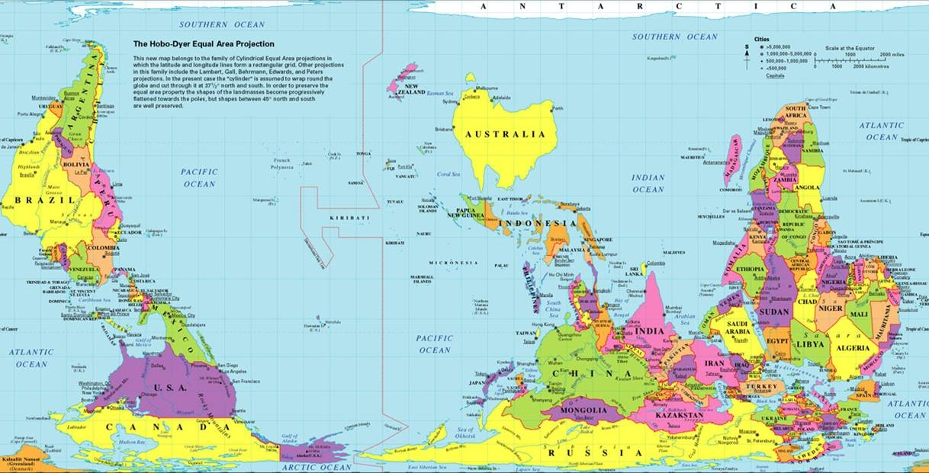

Here I generalise even more freely. There is a common effectiveness in the world, grounded in a similar self-confidence and practical gift. Perhaps the self-certainty is greater in the UK. Australia’s is partly borrowed from Britain. But as I’ve argued, Australians are also shaped by their location. Most no longer see the UK as home.

[Viewpoint2]

In the UK that sense of self-certainty is a strength and a weakness. It is hard for all but the dedicated Europeanists or Asianists in UK universities to understand that sometimes, we might have something to learn from non English-speaking others, as well as something to teach. So mostly, UK universities are l forced back on the old independent strategy of pulling themselves up by their own boot straps. It’s served them well up to know, but it is less clear it will do so in the future. Policy makers borrow successfully from Australians, whom they see was neither European nor Asian. Australians are part of the family.
For their part, Australians, always practical and pragmatic, less fixed and certain about themselves, learn from a wider range of sources, though more so from Europe than from Asia as yet. And they prefer to avoid the decisive choices about identity (England or Asia?). Though perhaps not for ever.

